**Lab5 Fall GRB LED**

To make RGB LED blink different colors through raspberry pi,

* Connect a LED with R, G and B pins connected through 220Ohm resistors and then to pins GPIO17, GPIO18 and GPIO27, ground pin to ground on the breadboard.
* Connect the GND of GPIO to ground on the breadboard.

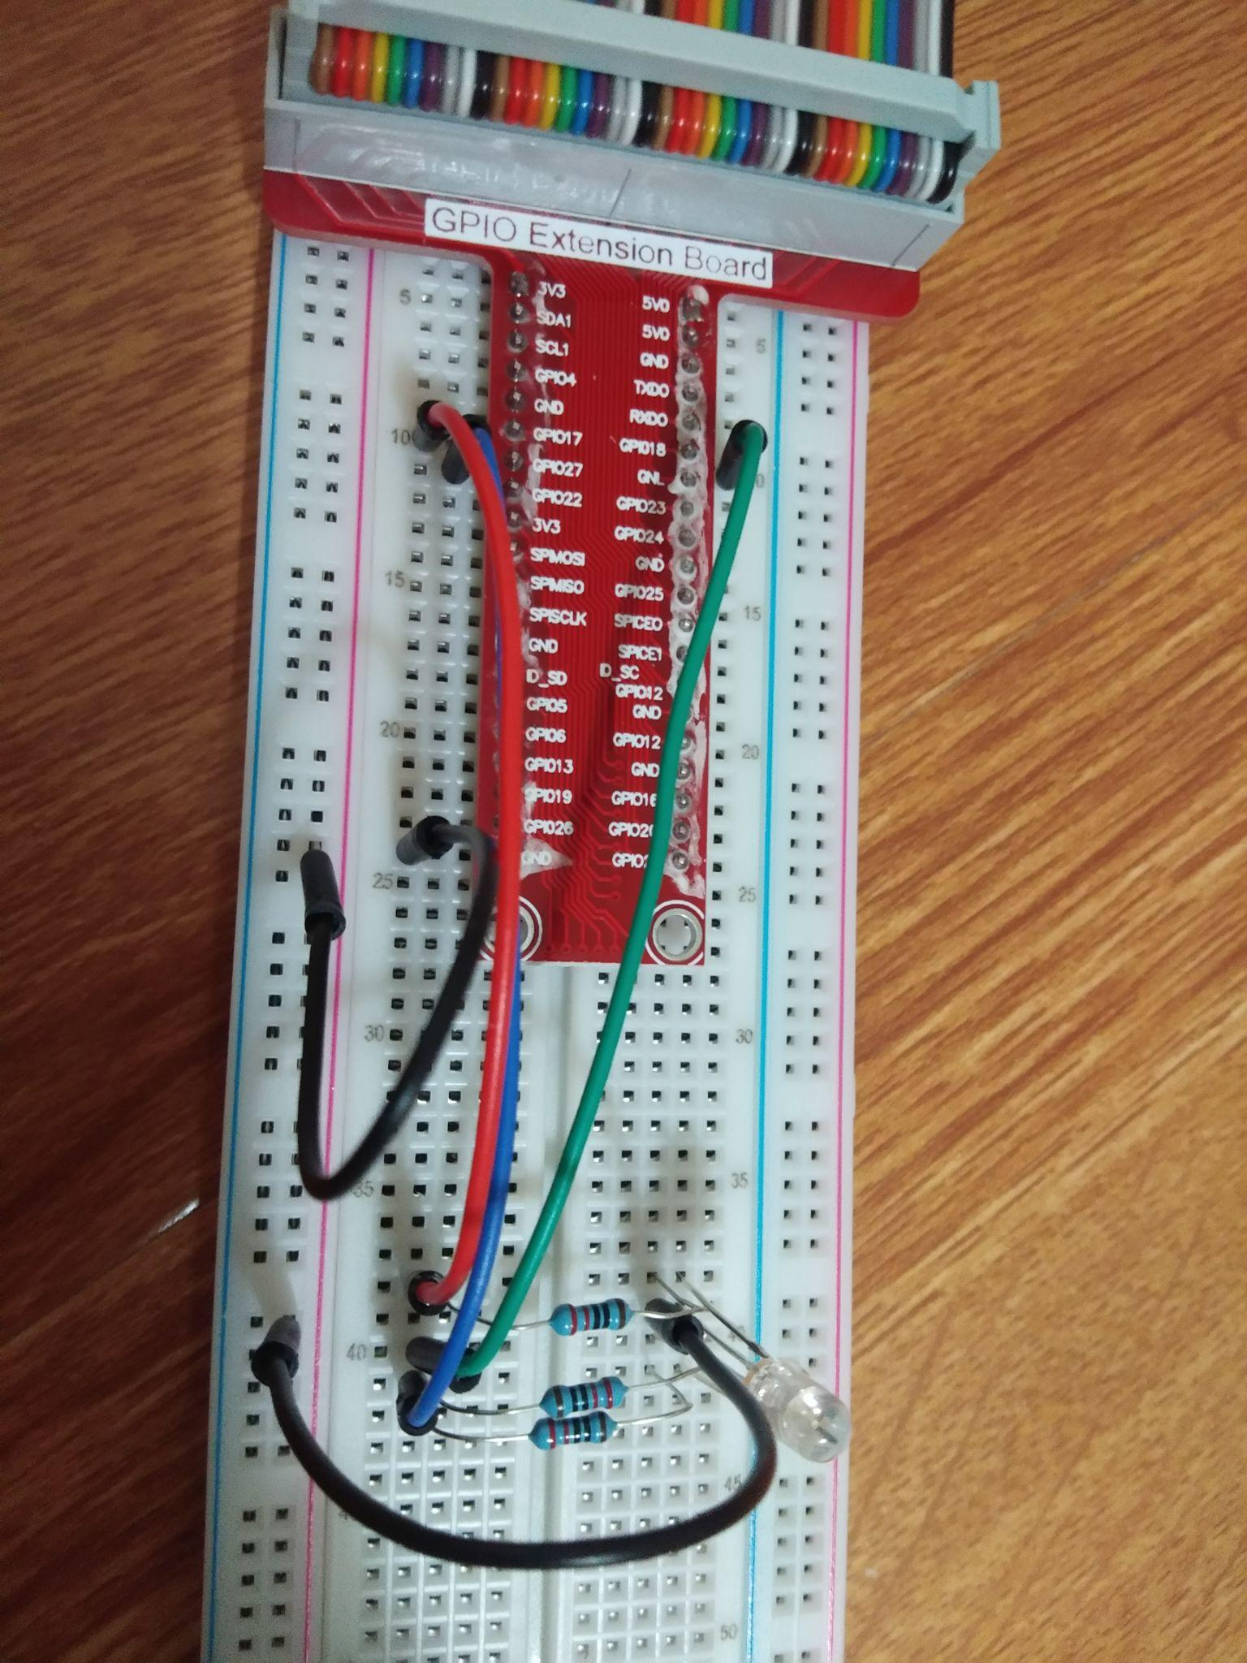

* Now give power supply to Raspberry pi.
* Connect the pi through VNC viewer.

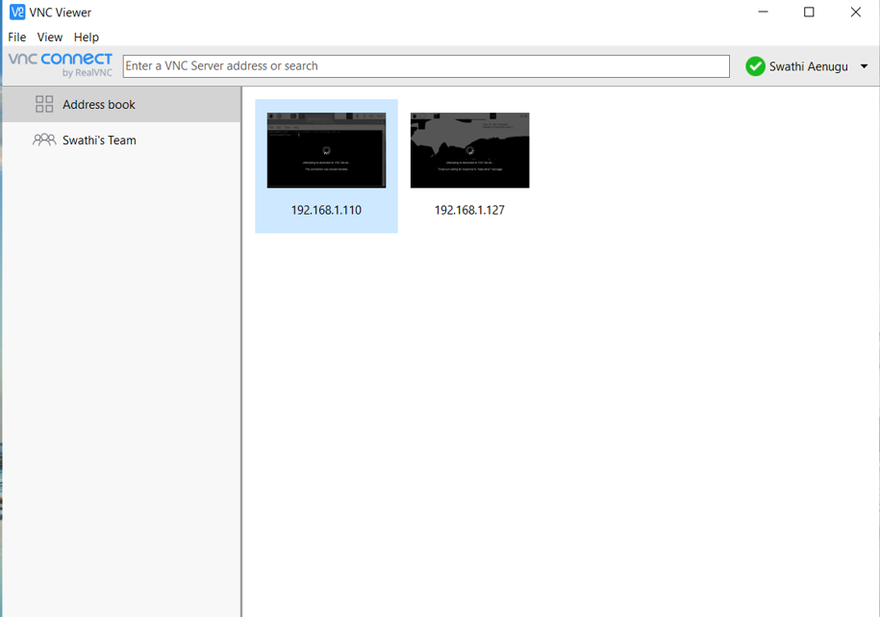

* Now open python and open a new file.

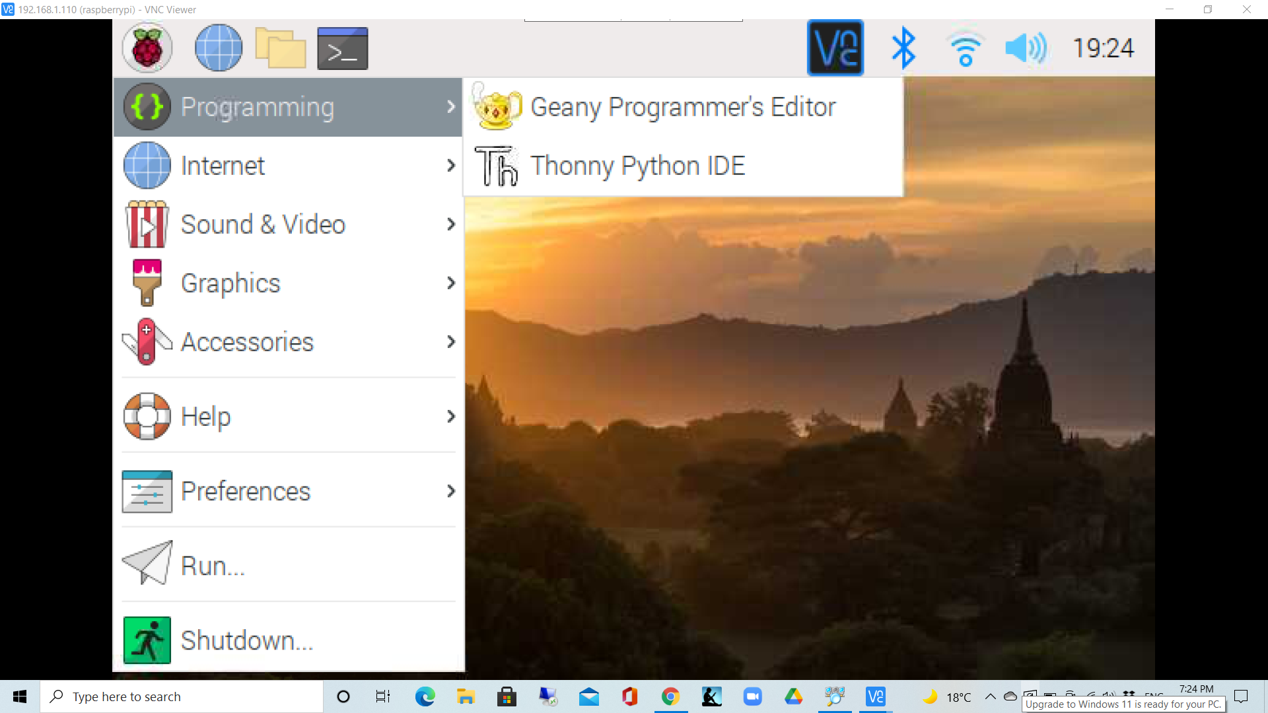

* Write the code to make RGB LED blink and save it with .py extension(RGB_LED.py)

**Code:**

import RPi.GPIO as GPIO

import time

colors = [0xFF0000, 0x00FF00, 0x0000FF, 0xFFFF00, 0xFF00FF, 0x00FFFF]

pins = {'pin_R':11, 'pin_G':12, 'pin_B':13} # pins is a dict data type

GPIO.setmode(GPIO.BOARD) # Numbers GPIOs by physical location

for i in pins:

GPIO.setup(pins[i], GPIO.OUT) # Set pins' mode is output

GPIO.output(pins[i], GPIO.HIGH) # Set pins to high(+3.3V) to switch on led

p_R = GPIO.PWM(pins['pin_R'], 2000) # set Frequency to 2KHz

p_G = GPIO.PWM(pins['pin_G'], 2000)

p_B = GPIO.PWM(pins['pin_B'], 5000)

p_R.start(0) # Initial duty Cycle = 0(leds off)

p_G.start(0)

p_B.start(0)

def map(x, in_min, in_max, out_min, out_max):

return (x - in_min) * (out_max - out_min) / (in_max - in_min) + out_min

def setColor(col): # For example : col = 0x112233

R_val = (col & 0xFF0000) >> 16

G_val = (col & 0x00FF00) >> 8

B_val = (col & 0x0000FF) >> 0

R_val = map(R_val, 0, 255, 0, 100)

G_val = map(G_val, 0, 255, 0, 100)

B_val = map(B_val, 0, 255, 0, 100)

p_R.ChangeDutyCycle(R_val) # Change duty cycle

p_G.ChangeDutyCycle(G_val)

p_B.ChangeDutyCycle(B_val)

try:

while True:

for col in colors:

setColor(col)

time.sleep(0.5)

except KeyboardInterrupt:

p_R.stop()

p_G.stop()

p_B.stop()

for i in pins:

GPIO.output(pins[i], GPIO.HIGH) # Turn off all leds

GPIO.cleanup()

* Now to make the RGB LED blink, run the program
* Sudo python rgb_led.py

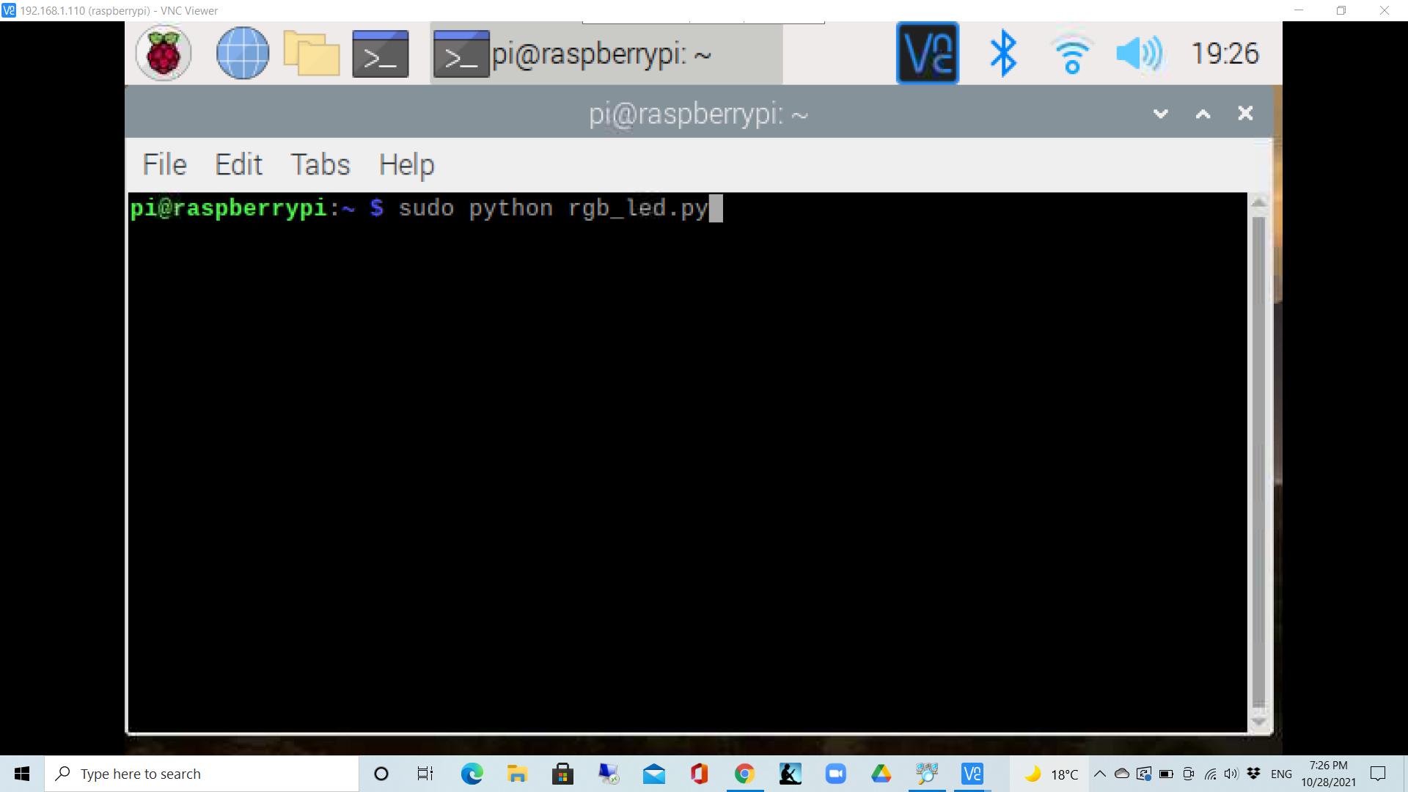

* Now RGB LED starts blinking
* To stop the RGB LED blink, press ctrl+C

**OUTPUT:**  
Link for output video:

<https://drive.google.com/file/d/1365HBRU7Ot5zJnpRY5tmyediaWMFztAD/view?usp=sharing>